MODULE 5

Que 1
https://leetcode.com/problems/power-of-two/description/
Code
#include <stdio.h>
bool isPowerOfTwo(int n) {
if (n <= 0) {
return false;
}

return (n & (n - 1)) == 0;
}

Output
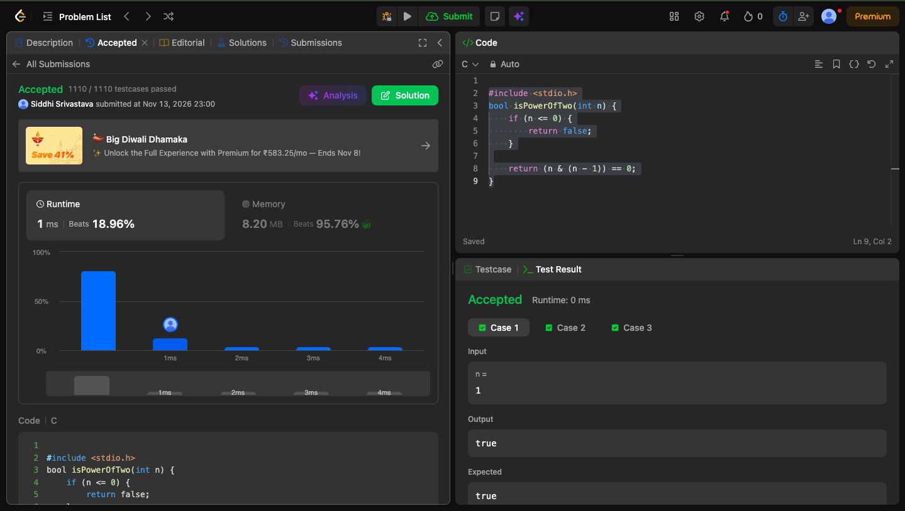

Que 2

https://leetcode.com/problems/power-of-three/

Code
#include <stdio.h>
bool isPowerOfThree(int n) {
if (n <= 0) {
return false;
}
while (n % 3 == 0) {
n /= 3;
}
return n == 1;

}

Output
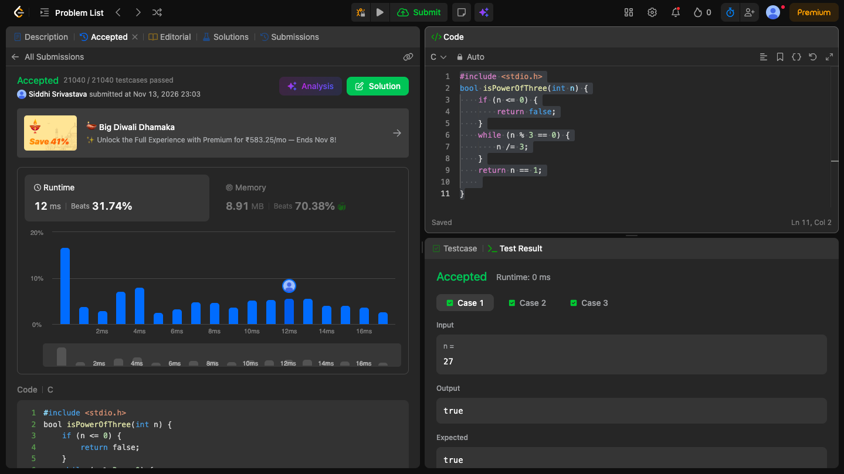

Que 3
Code
#include <stdio.h>

int main(){
int num;
scanf("%d", &num);
long long factorial = 1;

for (int i = 1; i <= num; i++) {
factorial *= i;}

printf("%lld\n", factorial);

return 0;

}

Output
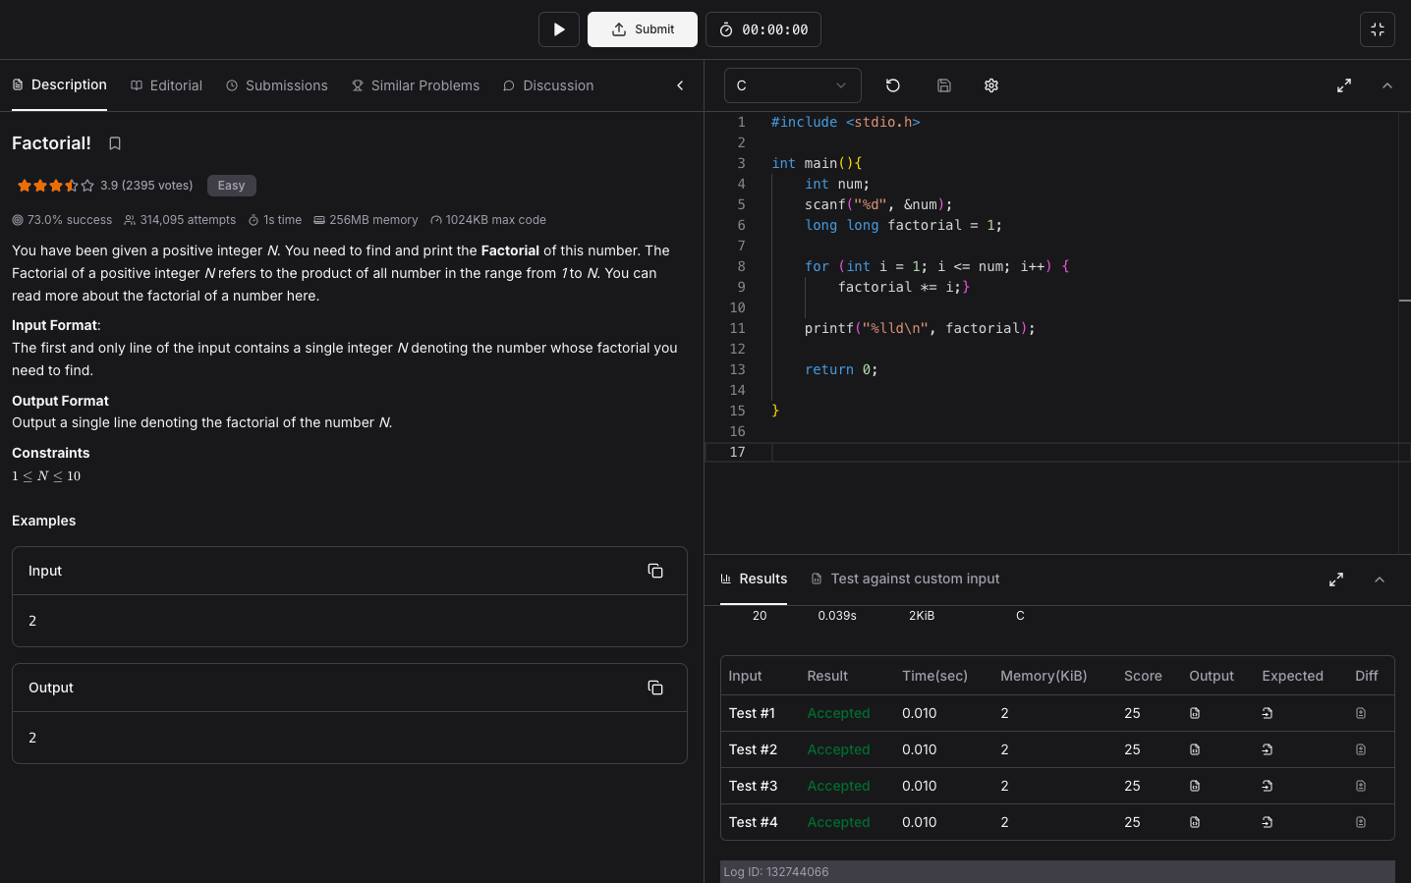

Que4

https://www.hackerearth.com/practice/basic-programming/input-output/basics-of-input-output/practice-problems/algorithm/count-divisors/

Code
#include <stdio.h>

int main(){
int l, r, k;
scanf("%d %d %d", &l, &r, &k);
int count = 0;

for (int i = l; i <= r; i++) {
if (i % k == 0) {
count++;
}
}
printf("%d\n", count);

return 0;}

Output
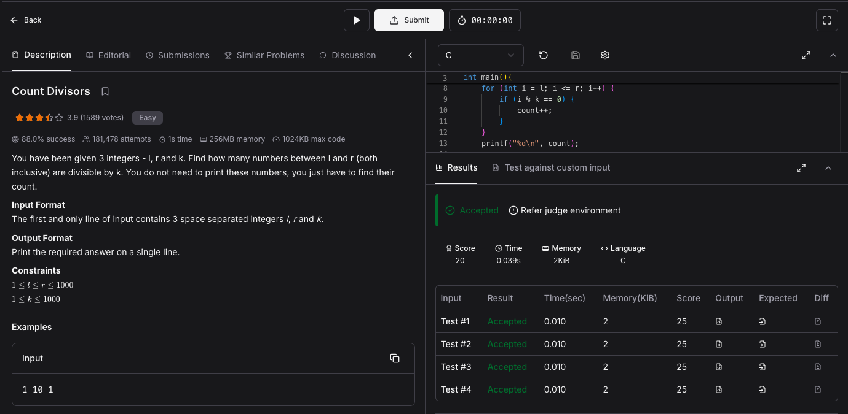

Que 5
https://www.hackerearth.com/problem/algorithm/prime-numbers/

Code
#include <stdio.h>

int main(){
int n;
scanf("%d", &n);

int is_prime = 1;

if (n <= 1) {
is_prime = 0;
} else {
for (int i = 2; i * i <= n; i++) {
if (n % i == 0) {
is_prime = 0;
break;
}
}
}

if (is_prime) {
printf("1\n");
} else {
printf("0\n");
}

return 0;
}

Output
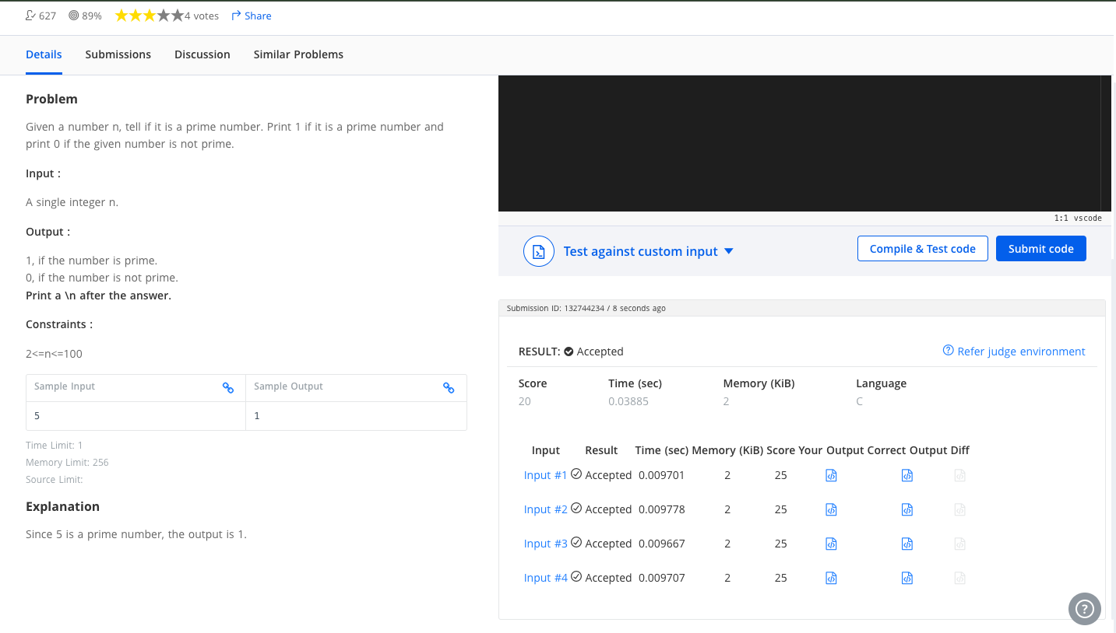

Que 6
https://leetcode.com/problems/perfect-number/description/
CODE
bool checkPerfectNumber(int num) {

if (num <= 1) {
return false;
}

int sum = 1; // 1 is always a proper divisor for num > 1

for (int i = 2; i * i <= num; i++) {
if (num % i == 0) {
sum += i;
if (i * i != num) {
sum += (num / i);
}
}
}

return sum == num;
}

OUTPUT


